**FORM INTERFACE**

* *Import* is used to get the value from drivers program or standard transactions

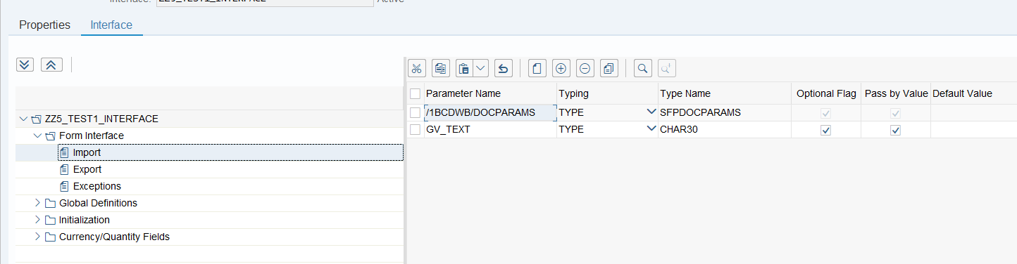

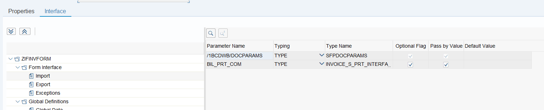

* *Export* passes the value to the drivers program.
* *Exceptions* are used to add and raise exceptions.

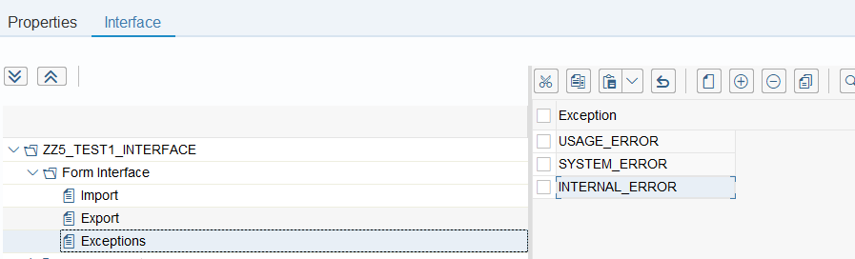

**GLOBAL DEFINITIONS**

* Global Data is used to declare the variable within the form. In type name you can use table type that is declared in data dictionaries or *TYPES*

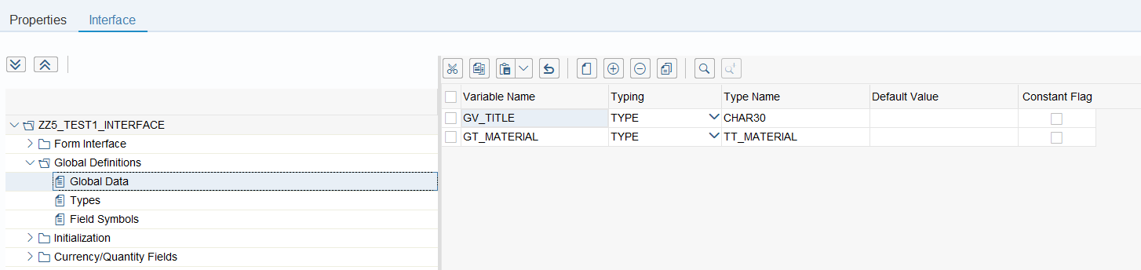

* *Types*. Used to declared types and used to global data

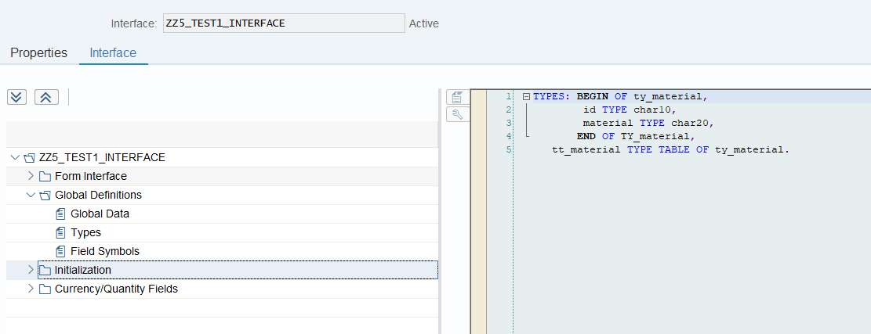

* *Field Symbols*. Used to declared field symbols same as global data

**INITIALIZATION**

* *Code Initialization*. Used to initialize value in Global data. You can access *Global data* and *Types* except the type table

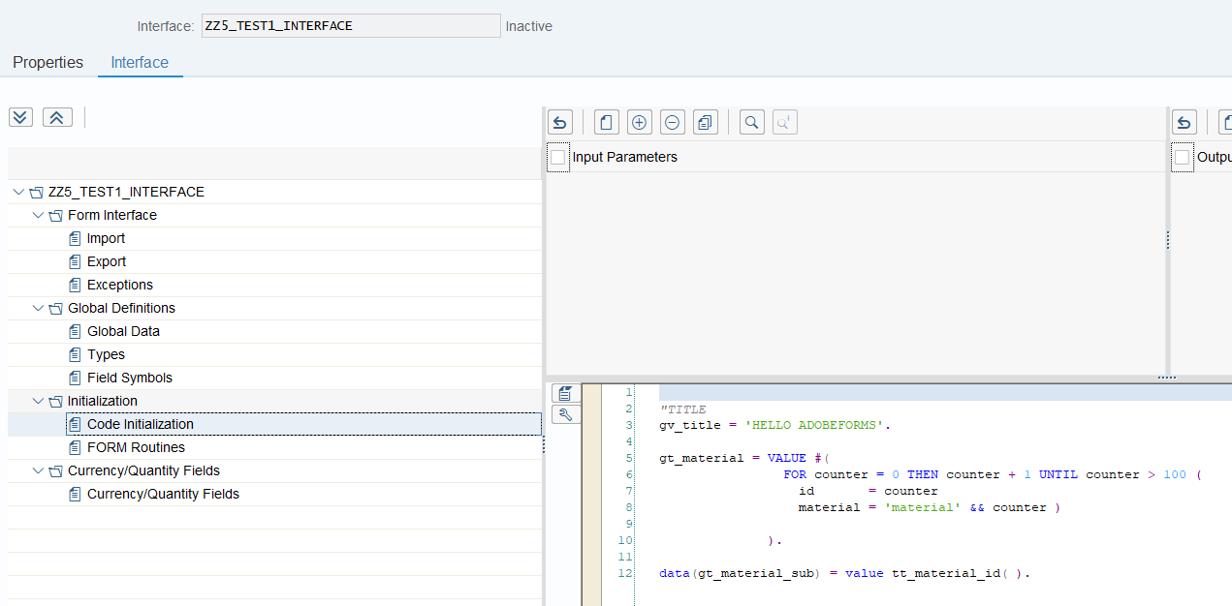

* *Form Routine*. Used to add form

**CURRENCY/QUANTITY FIELDS**

* *Currency/Quantity Fields*.

